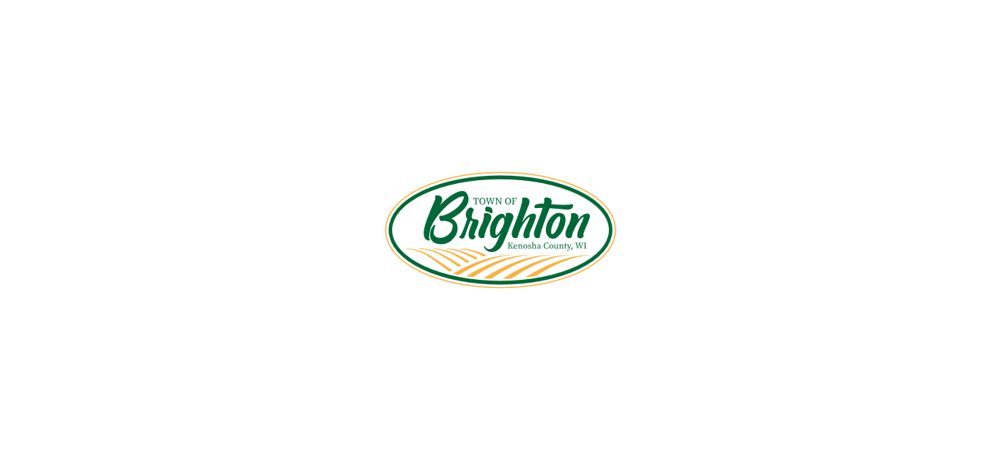
25000 Burlington Road, P.O. Box 249 Kansasville, WI 53139
Phone: 262-878-2218
E-mail: clerk-treasurer@brightonwi.org Web site: www.brightonwi.org

NOTICE OF PUBLIC HEARING

Notice is hereby given that the Town of Brighton Plan Commission will hold a public hearing on March 5, 2025, at 6:00pm at Town Hall (25000 Burlington Road, Kansasville, WI 53139) for the following:

      - Charles R. & Arlene Weyrauch, 27210 60th St., Salem, WI 53168-9504 (Owner), requesting a rezoning from C-2 Upland Resource Conservancy Dist. to C-2 Upland Resource Conservancy Dist. & C-1 Lowland Resource Conservancy Dist. on Tax Parcel #30-4-220-333-0100, located in the southwest ¼ of Section 33, T2N, R20E, Town of Brighton.

      - Charles R. & Arlene Weyrauch, 27210 60th St., Salem, WI 53168-9504 (Owner), requesting a Certified Survey Map on Tax Parcel #30-4-220-333-0100, located in the southwest ¼ of Section 33, T2N, R20E, Town of Brighton.
Notice is further given that printed copies of the proposed are available for public inspection at the Town Hall during regular hours of the Town Hall. During the Public Hearing, the public is invited to speak on the application. Written comments can also be submitted to the Town Clerk prior to the meeting and shall become part of the record. The Public Hearing shall be closed when all interested parties in attendance have had a chance to offer comment. Upon the close of the Public Hearing, the Plan Commission shall take up the remainder of its agenda.

Dated this 6th Day of February, 2025
Posted Date of February 17th, 2025 at Town Hall and on Town Hall Website
By: Angela Axton, Clerk-Treasurer




